777 Garner Rd. E. Ancaster, ON L9K 1J4
Telephone: 905-648-2139, ext. 4405
Fax: 905-648-2134
Email: teach@redeemer.ca

Associate Teacher Feedback Form

Thank you for your willingness to mentor a future teacher through the practicum placement.
Your guidance and support of the teacher candidate is greatly appreciated.

The School of Education at Redeemer University regularly examines how we can improve our program.

Please complete the information below and return it to <teach@redeemer.ca>
following the placement.

Name | Click or tap here to enter text.
School | Click or tap here to enter text.
What are components of the practicum that you see as particularly valuable?
Click or tap here to enter text.

Suggestions for improvement of the practicum:
Click or tap here to enter text.

Would you like someone to contact you about your suggestion of other items?
Click or tap here to enter text.

Thank you for your input

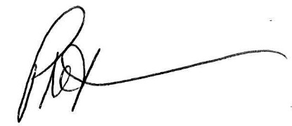

Phil Teeuwsen OCT, Ph.D.
Dean & Associate Professor, School of Education
Acting Practicum Supervisor, School of Education

