777 Garner Rd. E. Ancaster, ON L9K 1J4
Telephone: 905-648-2139, ext. 4405
Fax: 905-648-2134
Email: teach@redeemer.ca

Associate Teacher,

As a requirement from Canada Revenue Agency, the Accounting Department of Redeemer University requires that, in order to grant you an honorarium, you have to provide us with your Social Insurance Number and your home address. This information will be kept confidential.

You will be paid an honorarium of $8.00 per day for this 6-week practicum. Thank you for your willingness to assist us in the Bachelor of Education Program at Redeemer University.

Please complete the information below and return it to <teach@redeemer.ca> as soon as possible.
______________________________________________________________________________________________

Name | Click or tap here to enter text.
Home Address: | Click or tap here to enter text.
 | Click or tap here to enter text.
 | Click or tap here to enter text.
 | Click or tap here to enter text.
Social Insurance Number | Click or tap here to enter text.
Name of Teacher Candidate | Click or tap here to enter text.

Sincerely,

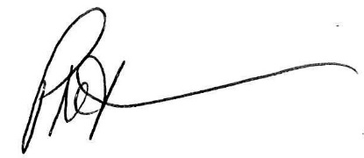

Phil Teeuwsen OCT, Ph.D.
Dean & Associate Professor, School of Education
Acting Practicum Supervisor, School of Education

